REPORT ON STUDENT INDUCTION PROGRAM (SIP)
Session: 2025–26
Course: BCA (Bachelor of Computer Applications)
Department: Computer Science
Institution: Government College for Women, Faridabad
Under: AICTE–NEP Guidelines
Duration: 3 Weeks

Objective of the Program
The primary aim of the Student Induction Program (SIP) is to familiarize new students with the academic environment, institutional culture, and essential life skills. It ensures a smooth transition from school to college by promoting socialization, physical and mental wellness, and foundational learning.
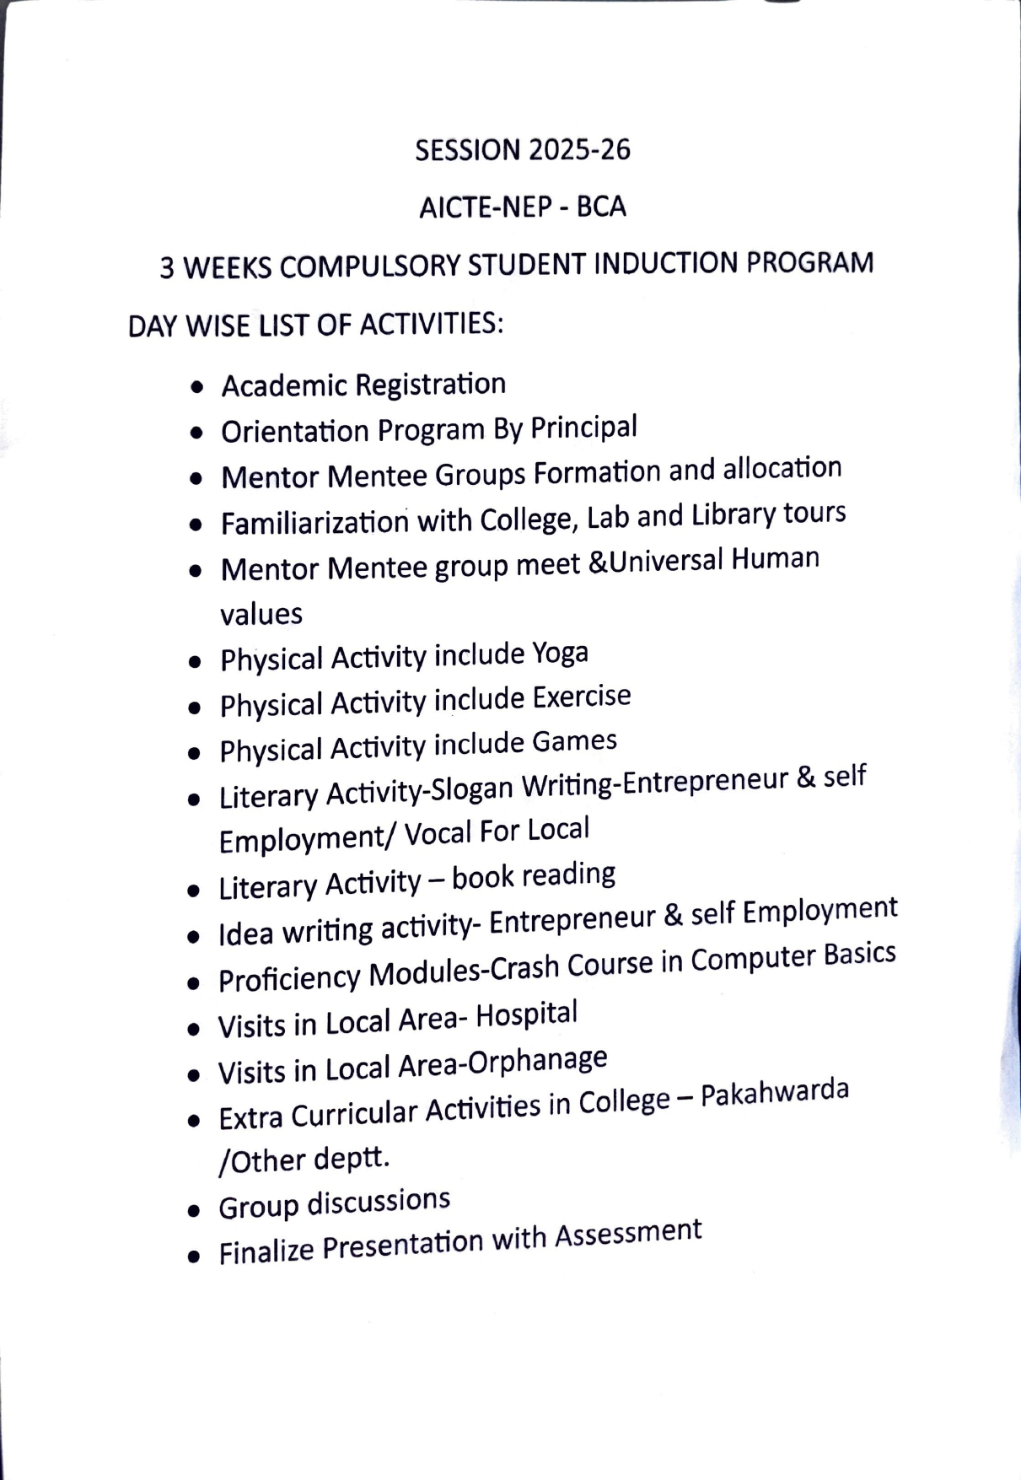

Day-Wise Activities Summary
- Academic Formalities
  - Registration of new students
The original documents of BCA 1st Year students were verified by Dr. Poonam Almadi and Meenu sheoron as part of the admission and enrollment process for the academic year 2025-2026. The verification process was conducted to ensure the authenticity and accuracy of the submitted academic and identity-related documents.
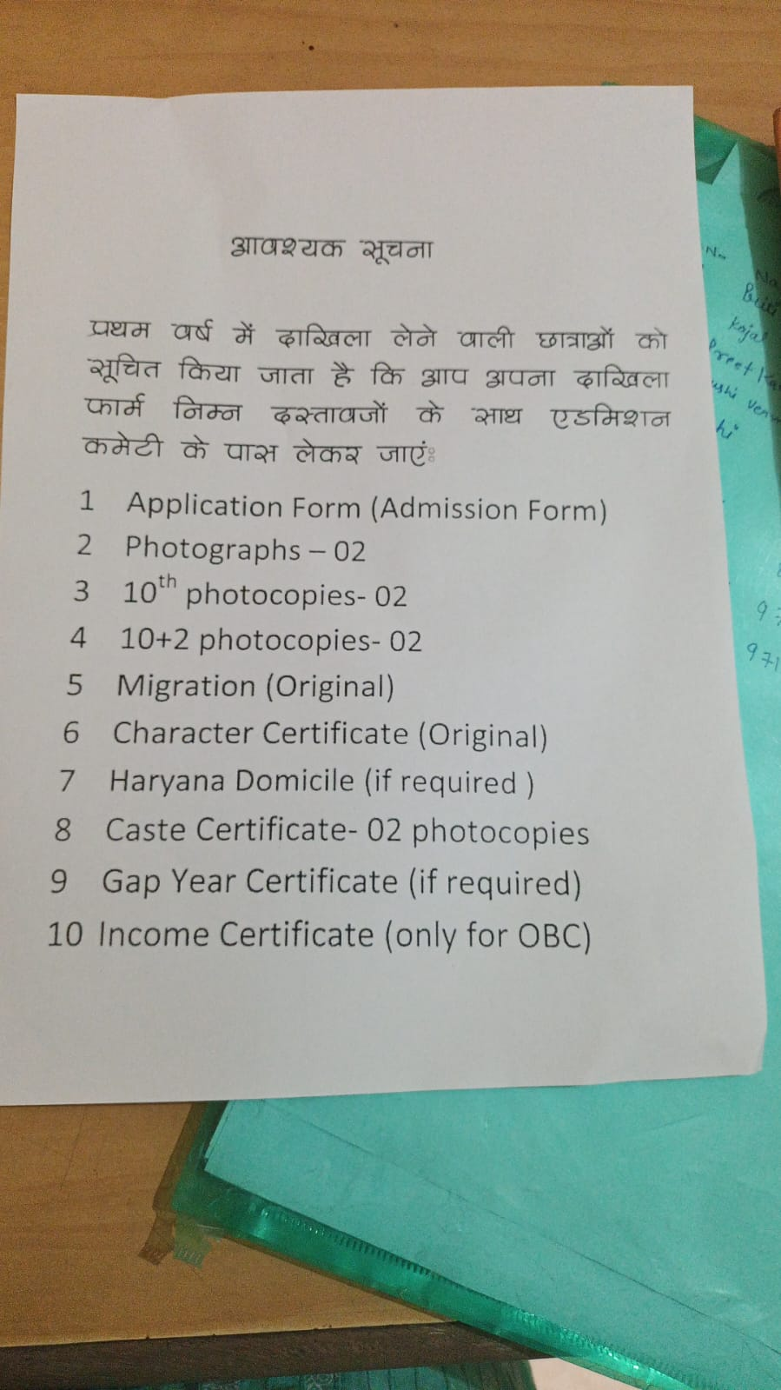
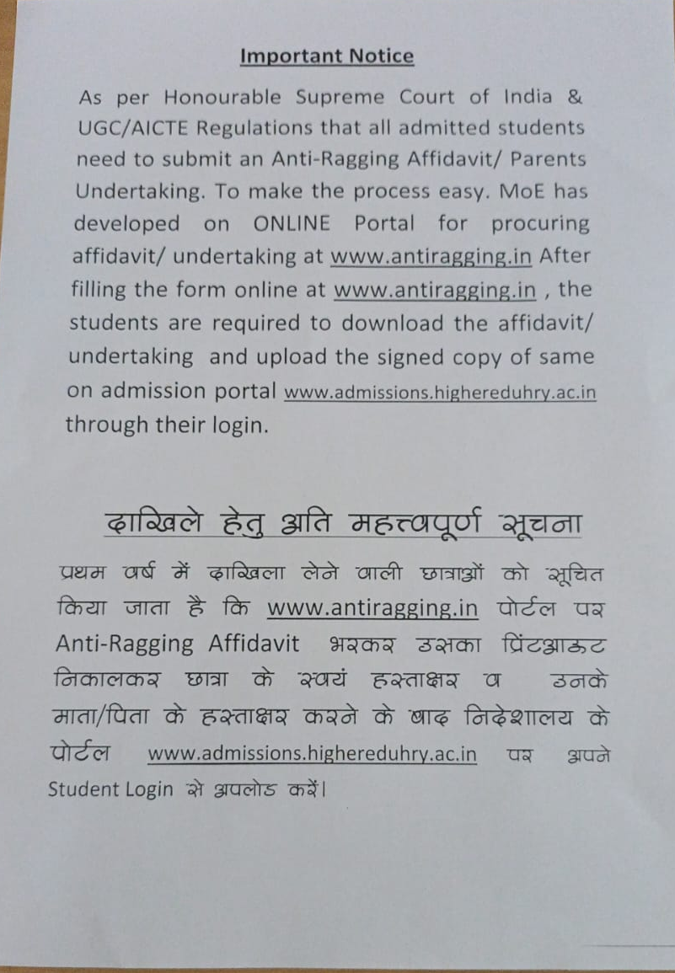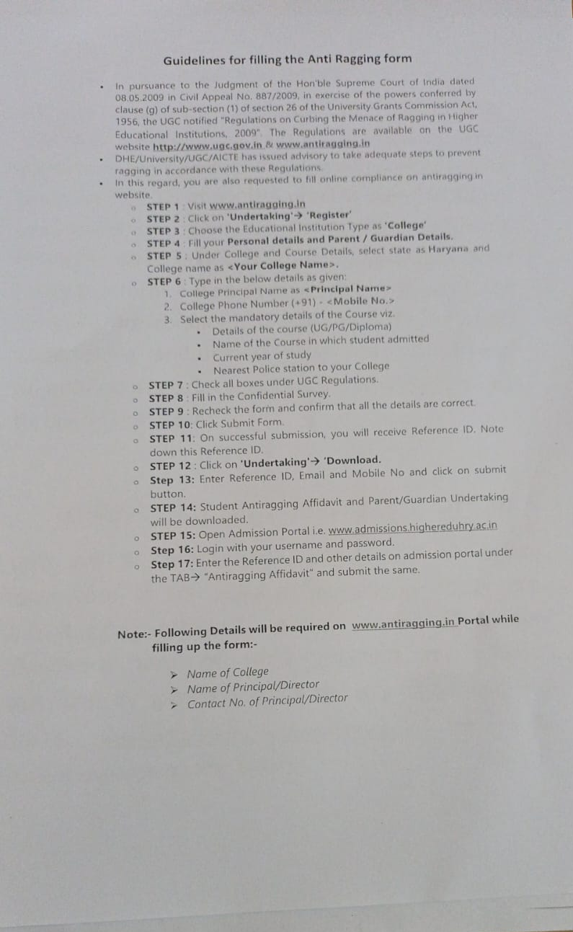

  - Orientation session by the Principal
To welcome and integrate new members an orientation program organized in the college campus on 12.08.2025
Objectives
The main objectives of the orientation program are to:
1. Familiarize new members with the vision, mission, and values of the institution/organization.
2. Provide information about rules, policies, and procedures.
3. Introduce key personnel, departments, and available support services.
4. Encourage interaction, networking, and team-building.
5. Build confidence and reduce anxiety about the transition.

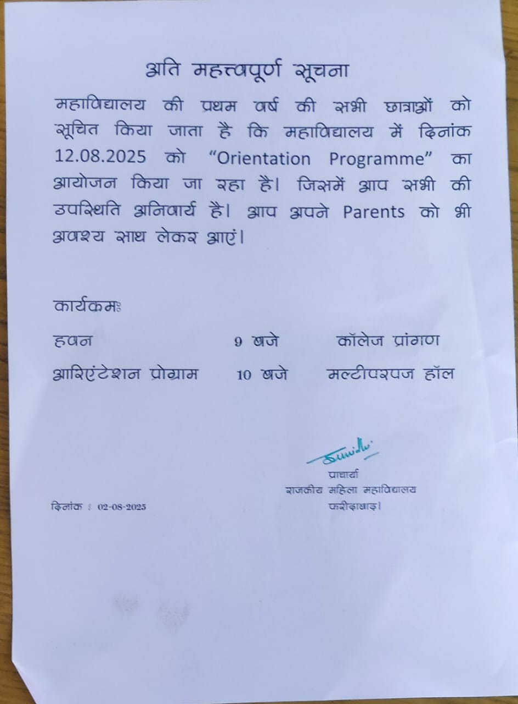

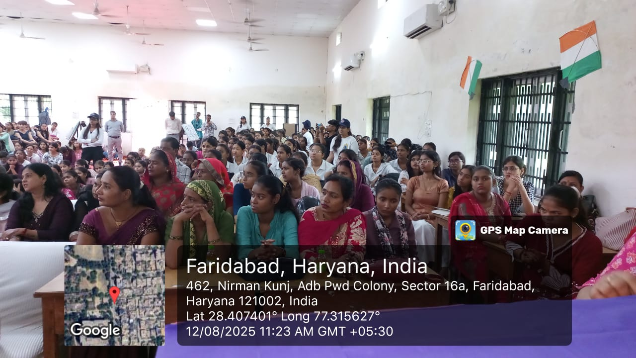
Formation of Mentor–Mentee groups and allocation
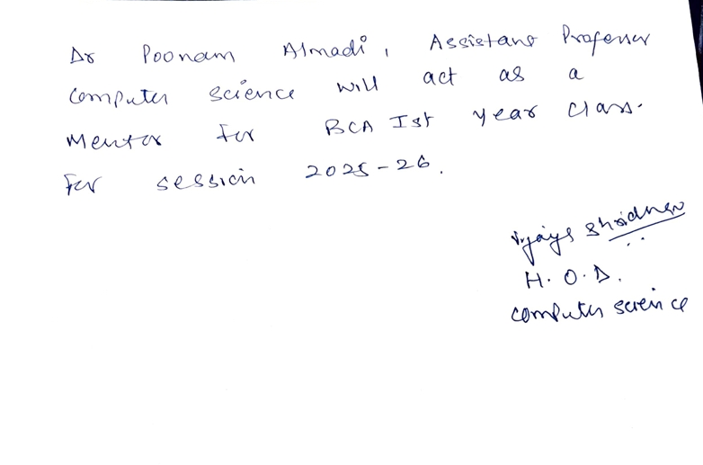

- Formation of Mentor–Mentee groups and Mentor-Mentee interactions
As part of the Mentor–Mentee initiative, a special session was conducted where Dr. Poonam Almadi, subject mentor, interacted with the newcomers of the department. She guided the students about their course structure and shared valuable insights regarding their upcoming 3–4 year academic journey. The interaction focused on the importance of discipline, consistency, and active participation in both academics and extracurricular activities. Students were encouraged to utilize every opportunity, ask questions freely, and work on skill development that will support their future careers. Adding to the motivation, our Principal addressed the students and reminded them that this journey is not just about academics but also about building character, confidence, and lifelong learning habits. Such mentor–mentee sessions not only provide academic direction but also instill confidence, positivity, and a sense of belonging among students, ensuring they are well-prepared for the path ahead.
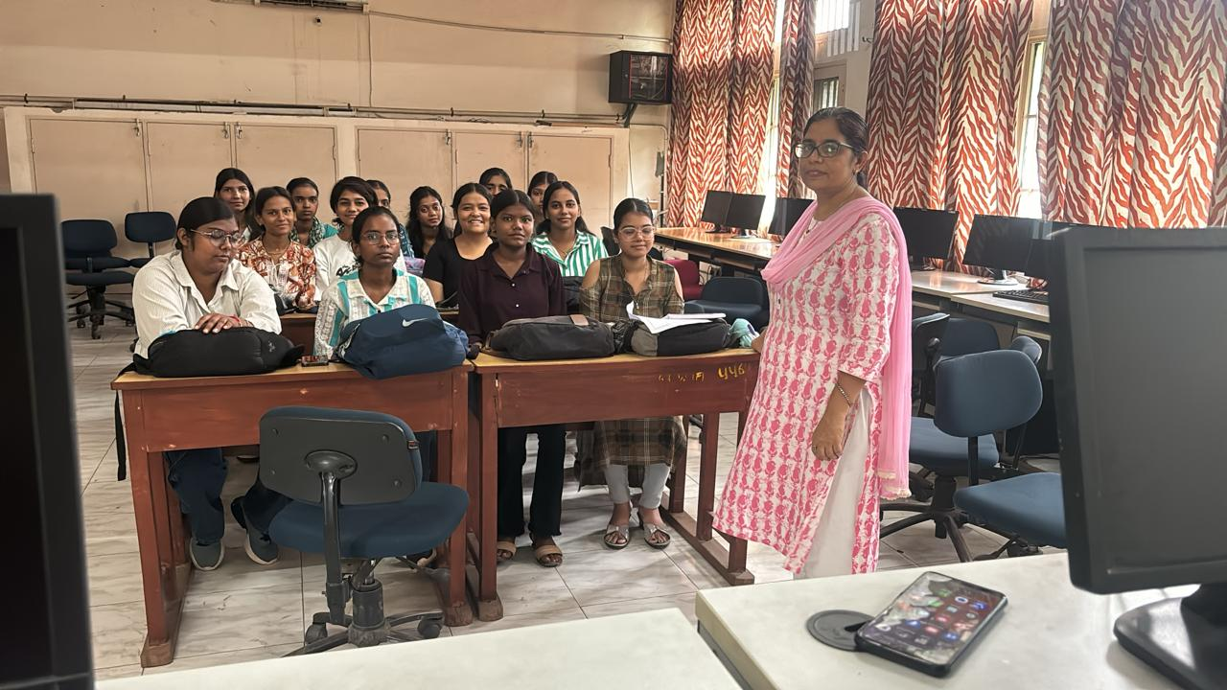

- Physical Activities
  - Physical fitness exercises
Students participating in the compulsory Yoga sessions organized under the 3-week Student Induction Program. The session focused on a combination of standing, seated, and relaxation asanas to improve flexibility, balance, and concentration. Students were seen performing foundational postures like Tadasana (Mountain Pose), Trikonasana (Triangle Pose), Vrikshasana (Tree Pose), Bhujangasana (Cobra Pose), and Setu Bandhasana (Bridge Pose). The practice also included pranayama techniques such as Anulom-Vilom (Alternate Nostril Breathing) and Bhramari (Humming Bee Breath) to enhance mental calmness and focus. Through these sessions, students learned to cultivate mind-body awareness, stress relief, and energy regulation, helping them begin their college journey with vitality and mindfulness.
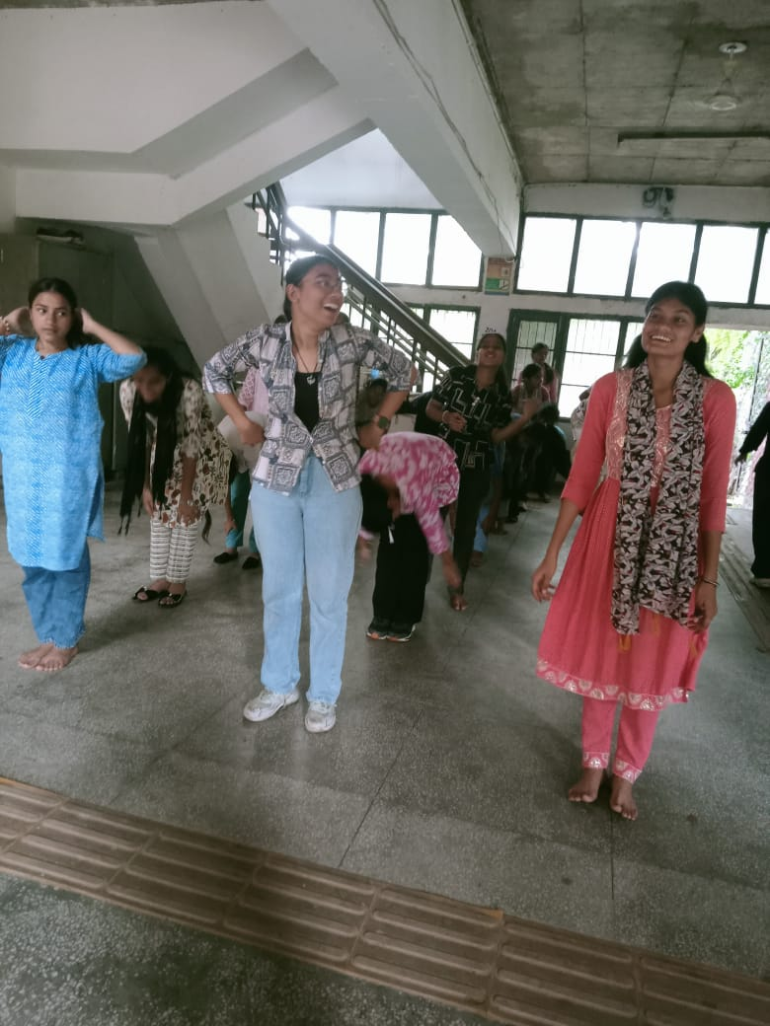
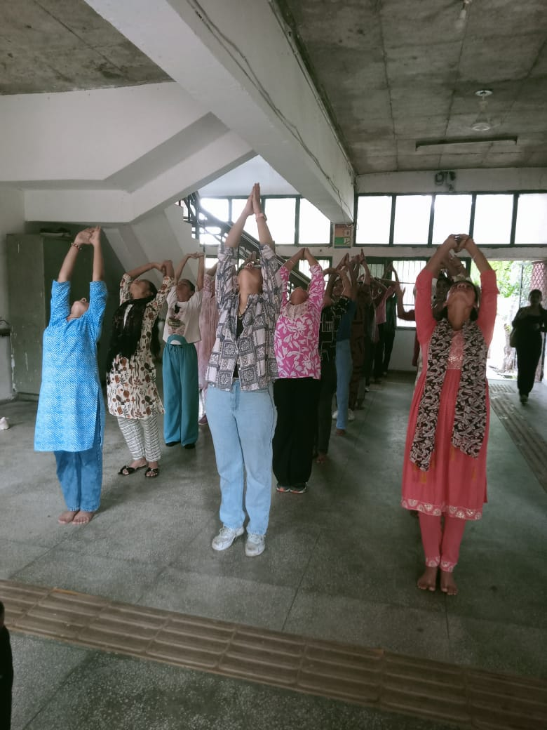
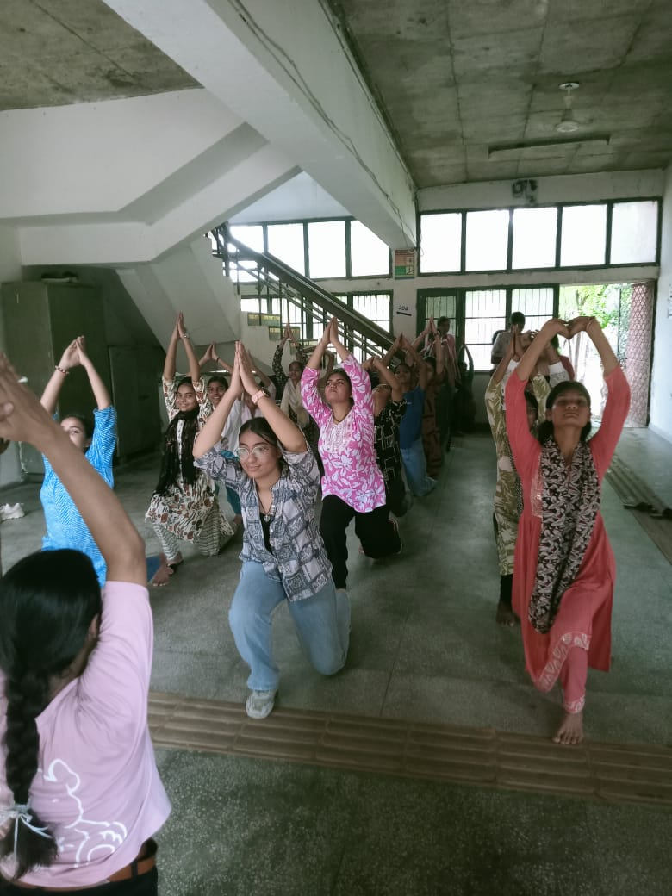
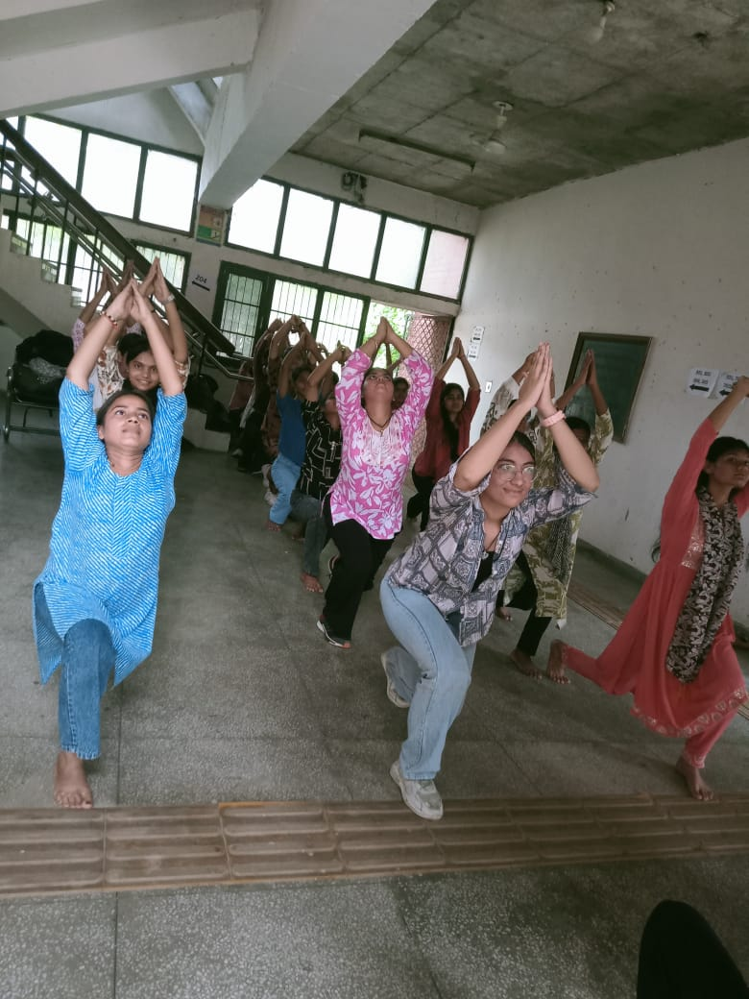
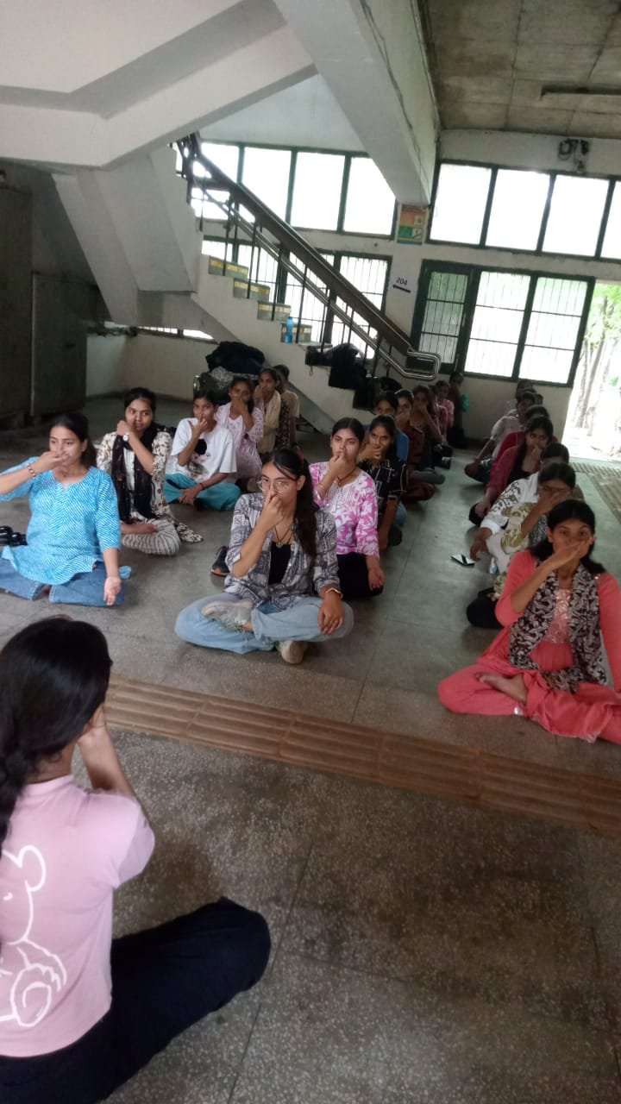
  - National Sports Day and Oath to Participate in indoor/outdoor games
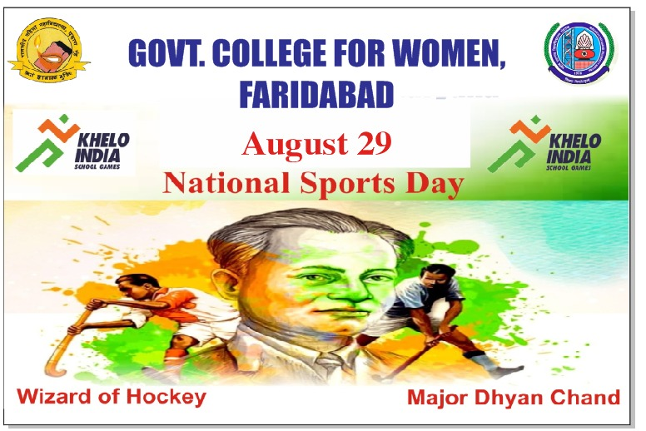

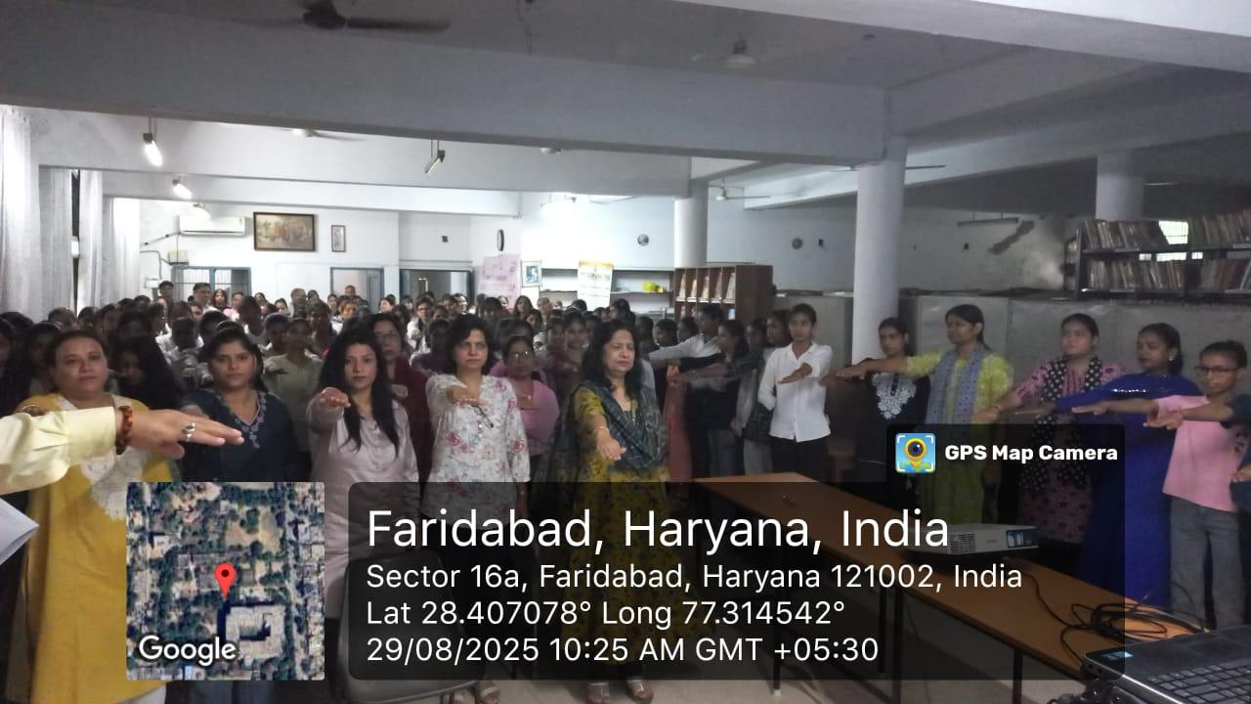
- Literary & Creative Activities
- Slogan Writing on themes like Entrepreneurship & Self-Employment
Students were allowed to submit slogans in either English or Hindi, and entries could be handwritten or typed. Objective was to encourage students to creatively express their thoughts on entrepreneurship and self-reliance through impactful slogans.
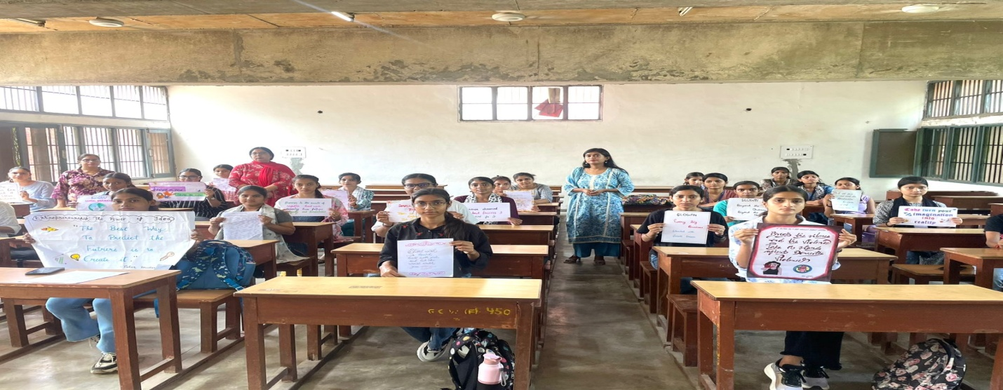

- Book Reading and reflection
As a part of the induction programme, a Reading in the Library activity was organized for the students. The objective of this activity was to familiarize the students with the library environment and to encourage the habit of reading. Students actively participated by selecting books, newspapers, and journals of their interest and spent dedicated time in reading. The peaceful and disciplined atmosphere of the library allowed them to focus and enjoy the process of self-learning. Through this activity, students understood the importance of libraries as a center of knowledge and were motivated to make regular use of this resource throughout their academic journey. It also helped them realize that reading enhances concentration, vocabulary, and overall personality development.
The activity proved to be a fruitful part of the induction programme, creating awareness about the role of reading in lifelong learning.
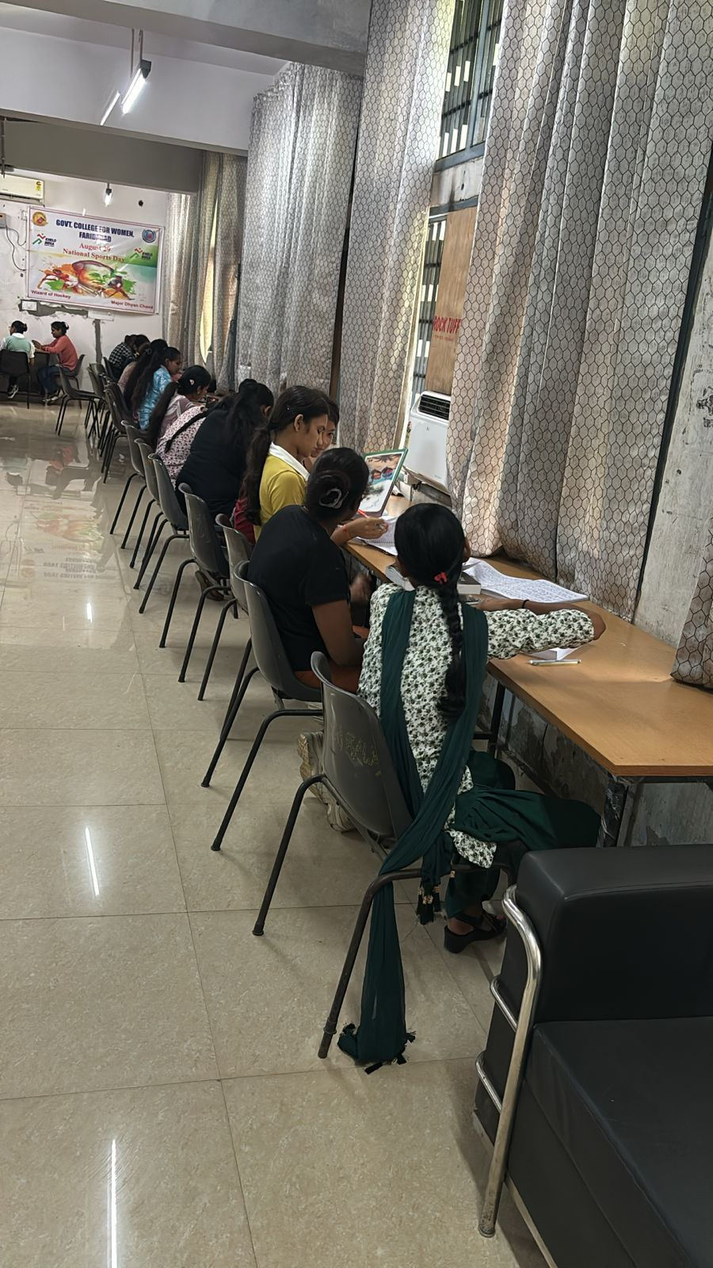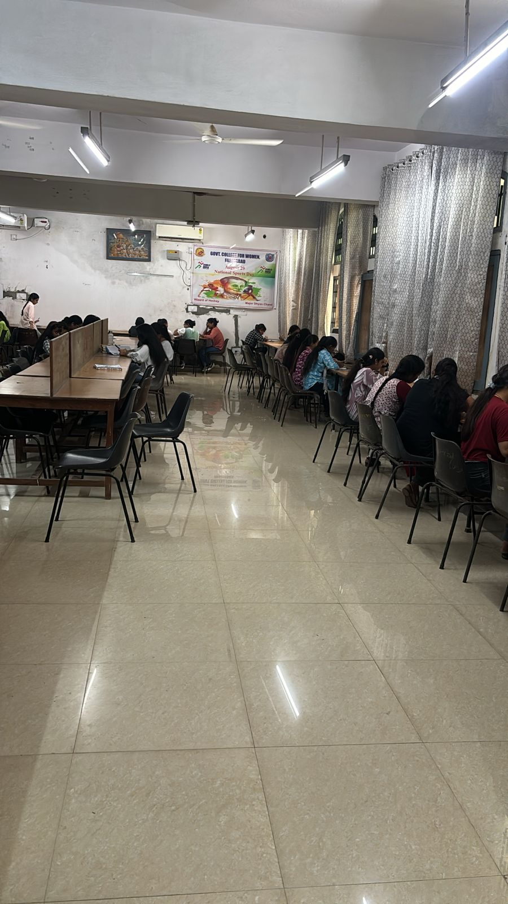
- Idea Writing competition on local entrepreneurship
Students were invited to submit a brief write-up (maximum 300 words) of their original startup ideas, focusing on innovation, sustainability, or social impact. Both individual and team entries (up to 3 members) were allowed in English or Hindi.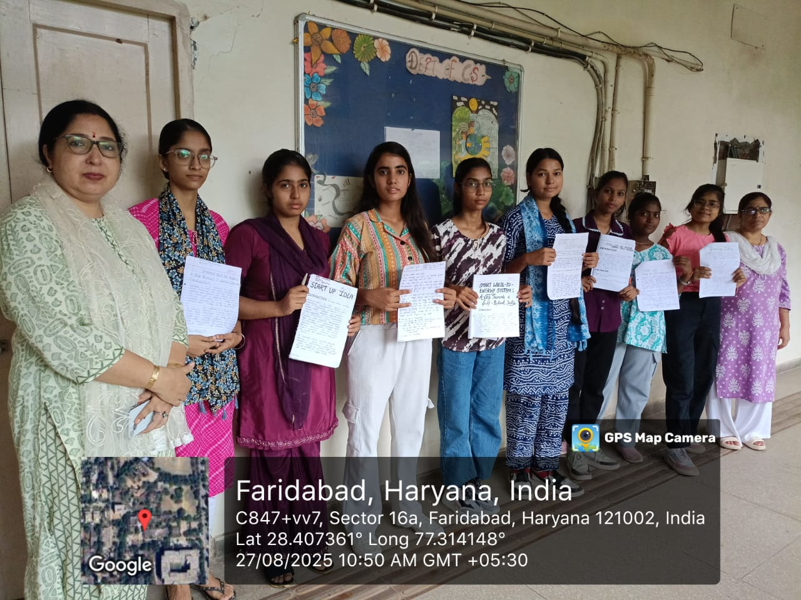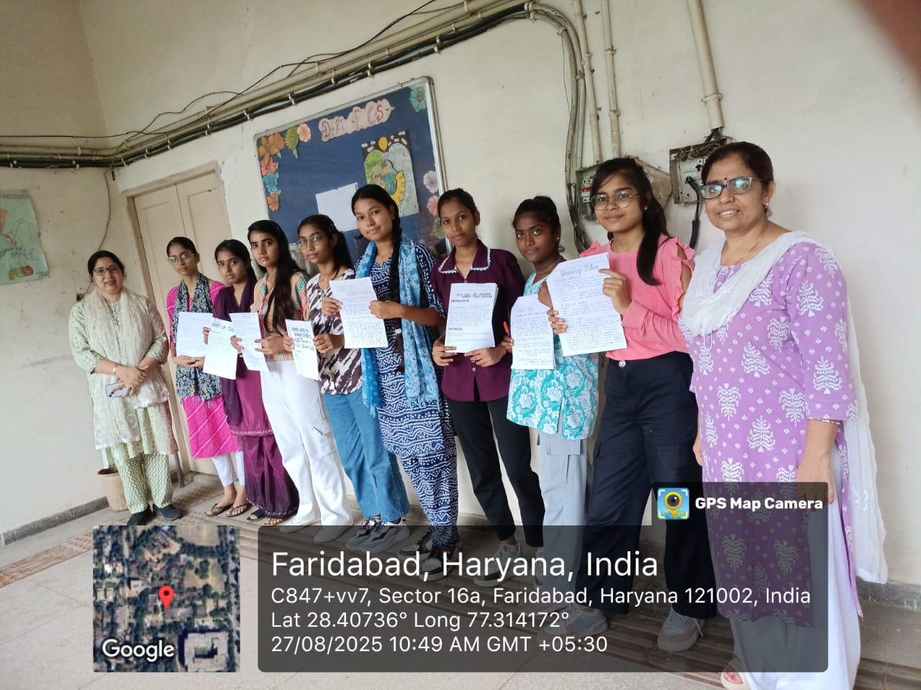
- Vocal for Local initiatives
• Skill Development
Government college for Womens on 3rd september 2025 , freshers students were introduced to the computer laboratory of department of computer science. The objective was to make student understand the basic hardware and software component and learn the rules and regulations for effective use of lab Dr Vijaya Sridhar explain the parts of the computer system such as CPU monitor keyboard mouse and close and regulations of the lab students also practiced operating the system in explode available softwares the activity help student to become comfortable with the lab environment and and created awareness about proper use and rules which will help in performing future computer based experiment and practical.

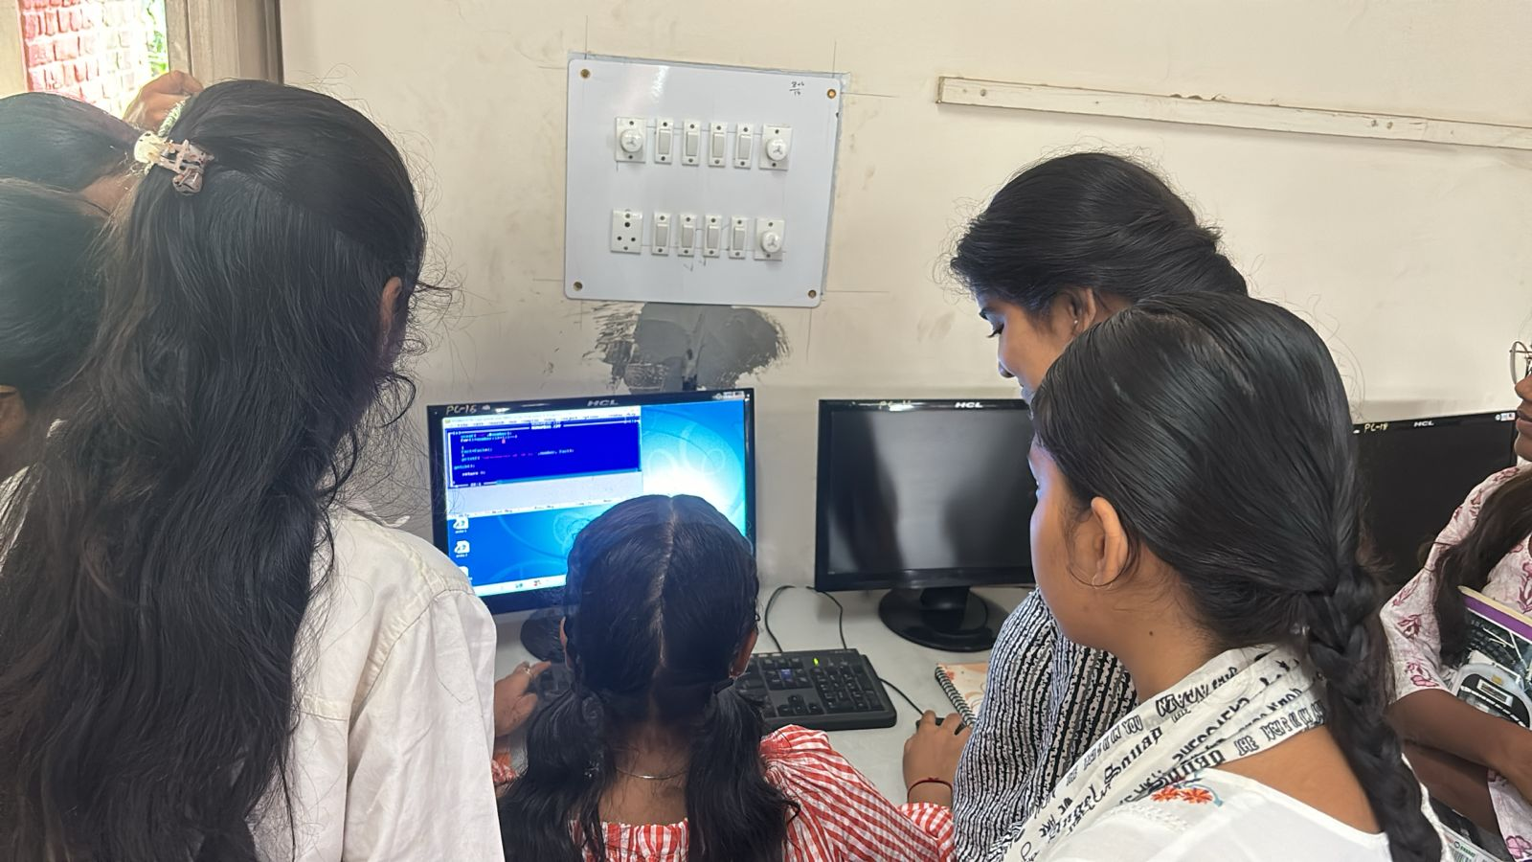
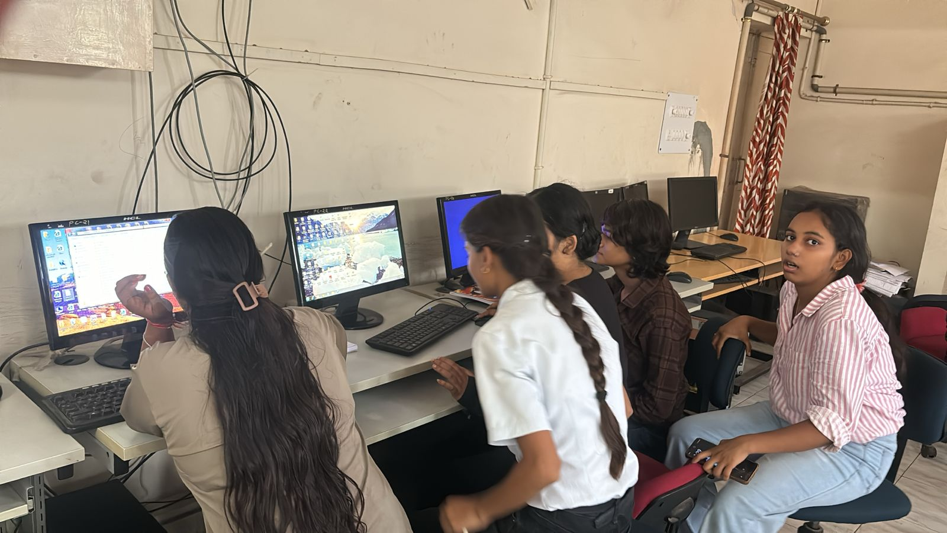
• Social & Community Visits
- Educational visits to Hospitals
A social visit to Metro Hospital, Faridabad was organized by the Computer Department, Government College for Women, Faridabad. The objective of the visit was to instill a sense of social responsibility and compassion among students by helping them understand the functioning of a healthcare institution and the importance of community health services.
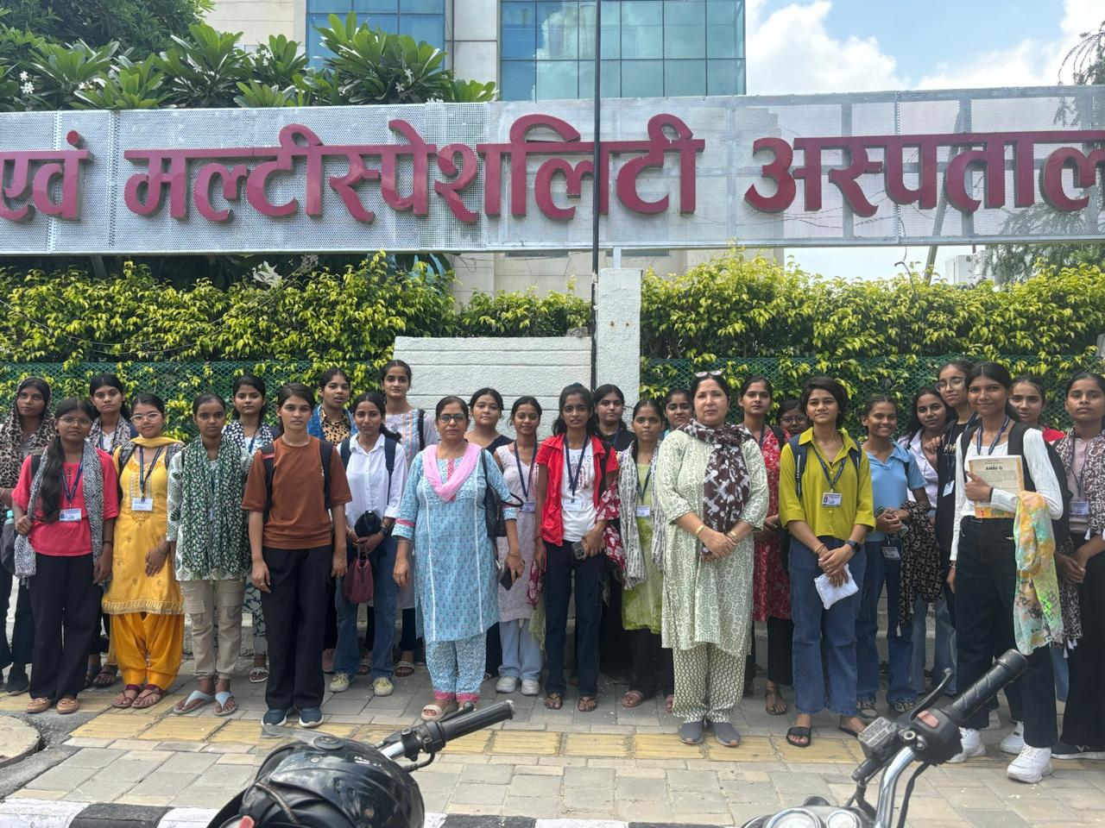

Awareness about Blood Donation

Blood Donation: A Noble Act of Saving Lives
Blood donation is a selfless act that plays a crucial role in saving lives. Every few seconds, someone in the world needs blood due to surgeries, accidents, or illnesses like cancer, anemia, or thalassemia. Despite medical advancements, there is no substitute for human blood, making voluntary blood donation a vital part of any healthcare system.

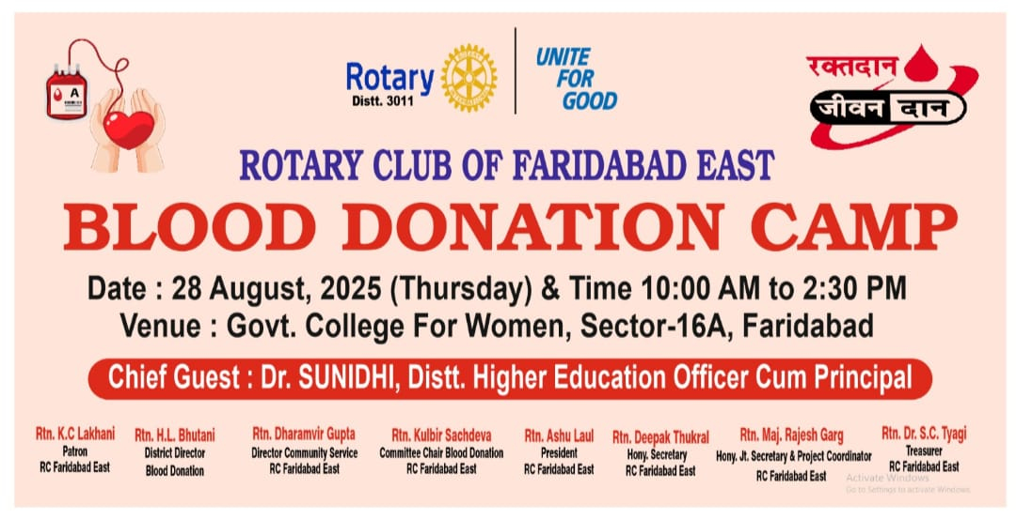
As part of the student induction program, awareness sessions and motivational talks on voluntary blood donation help instill values of compassion and service among students. Colleges often collaborate with local hospitals or NGOs to organize blood donation camps and first aid training sessions.

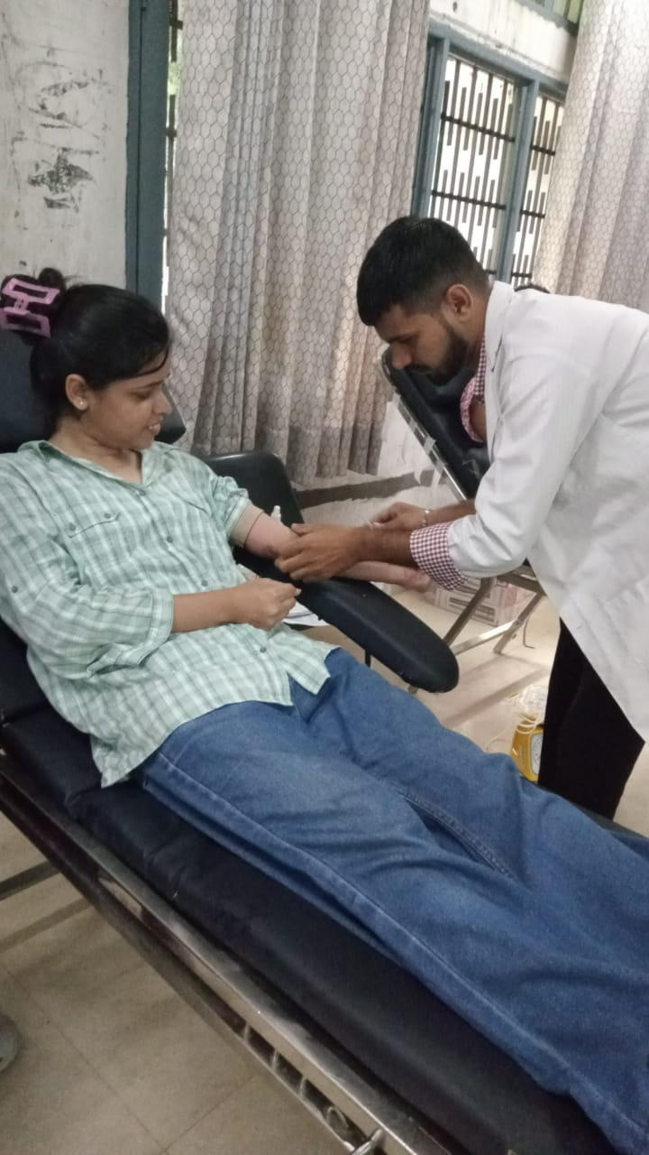
• Extra-Curricular Exposure
- Inter-departmental interactions through cultural and creative activities under Pakahwarda
- Participation in music, art, and departmental activities
• Group Discussions
- Peer interaction on contemporary and academic topics
- Confidence building and communication enhancement
• Final Presentation & Assessment
- Students presented their learning outcomes
- Assessment based on participation, creativity, and collaboration
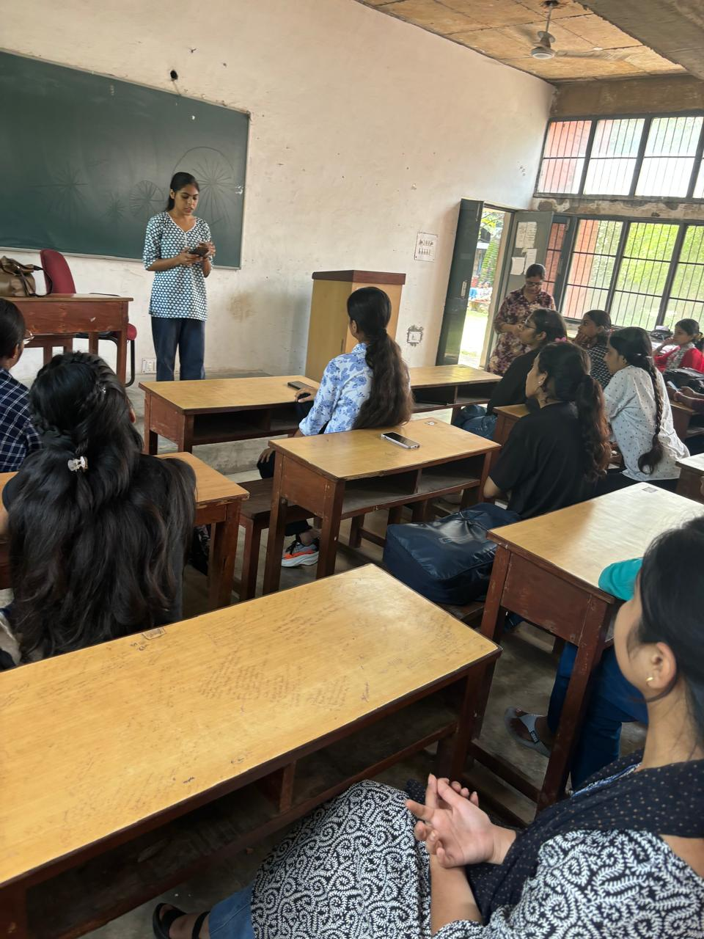

Outcome
- Enhanced student bonding and peer interaction
- Improved understanding of institutional functioning
- Initiated entrepreneurial thinking and self-reliance
- Familiarized students with basic computing skills
- Boosted physical and mental well-being

Acknowledgement
We sincerely thank our Principal Dr. Sunidhi, faculty members, mentors, and non-teaching staff for their invaluable contribution to successfully organizing the 3-week induction program.

Submitted By:
Department of Computer Science
Government College for Women, Faridabad

