Activities of placement cell for thesession 2025-26
Placement cell in collaboration with commerce and management department of Government College for Women, Faridabad has organised an insightful online webinar on 8th September 2025 at 11:00 AM for all students who are aiming to build a successful career in the finance and corporate sector.Approx 365 students attended the webinar.
The session was conducted by Ms. Khushi Gera, an experienced ACCA Affiliate, ACCA Faculty, and Ex-Audit Professional.Valubale tips and strategies to help students crack job opportunities in top firms were being discussed
Worthy Principal mam, Dr. Sunidhi also shared her views on the skills which are in demand in the industry as well as motivated students to ask querries.She encouraged the students to participate and make most of the opportunity.
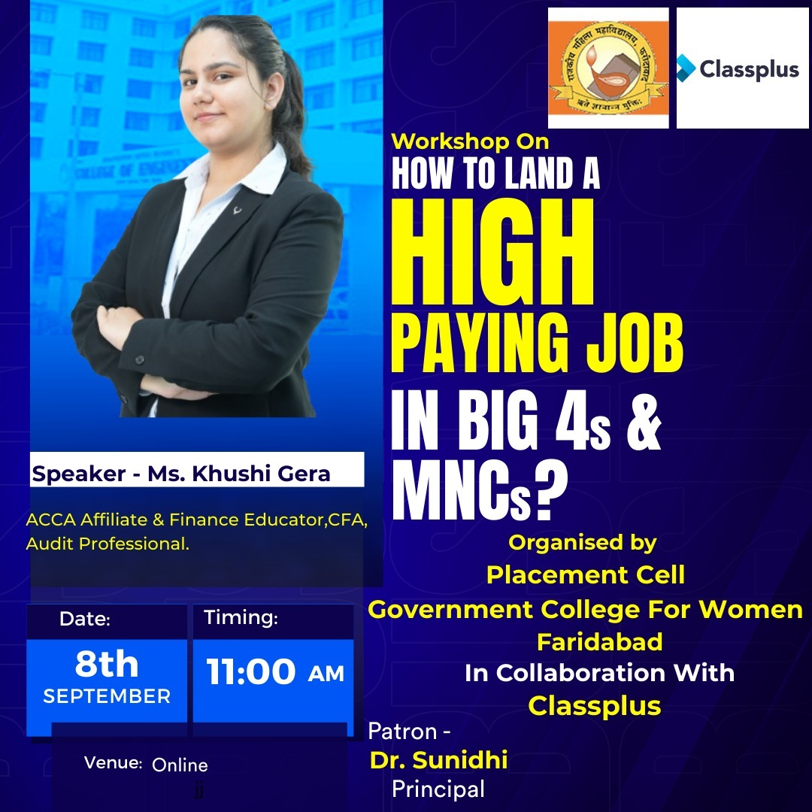
Placement cell members coordinated the event successfully.
Placement cell in collaboration with Commerce and management department of Govt College For Women has organised 2 day financial literacy program on 17th and 18th September 2025 .Kona kona Shiksha is a free financial literacy program by Kotak Securities Ltd. in partnership with NISM, aimed at final-year undergraduate and postgraduate students. Program has coverd basics of personal finance, investing, market risks, and career opportunities in finance. This program includes quizzes and certificates, helping students make informed financial decisions and prepare for careers in the financial sector.80 students participated in the program. Principal mam appreciated the efforts and informed students about the importance of being financially independent.. The event was well-organized and successfully executed by all members of the Placement Cell.
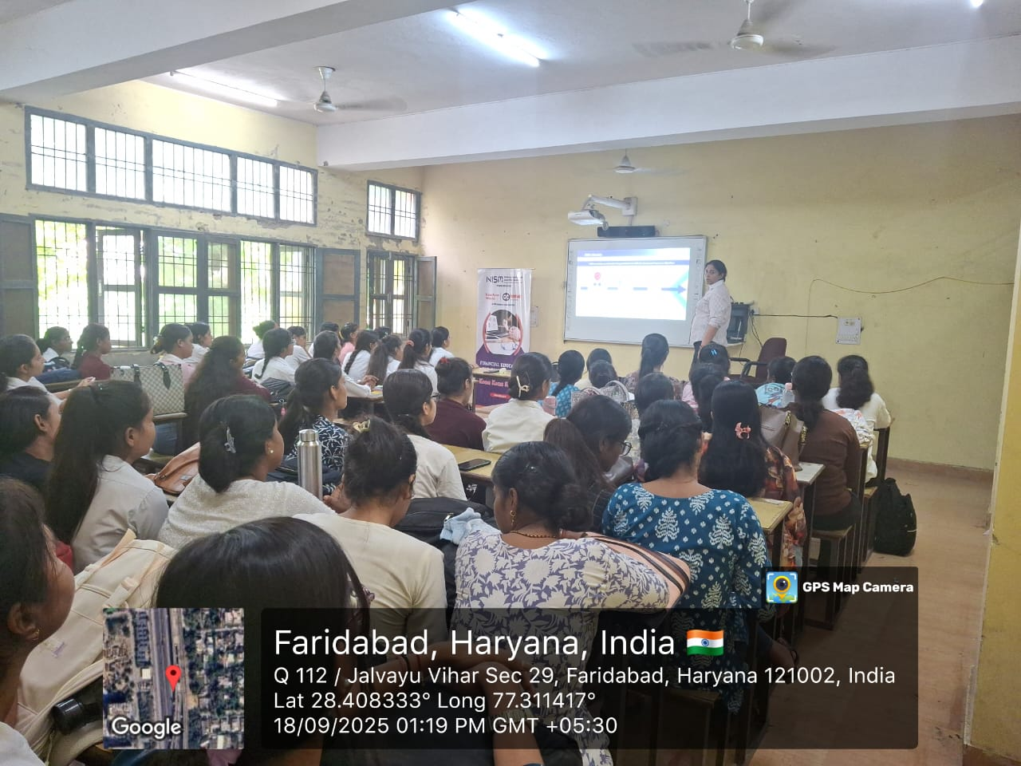
The Placement Cell of Government College for Women, Faridabad, in collaboration with the Department of Commerce, organized a seminar on "Employment Opportunities in Government Departments" on 9 September 2025. The resource person for the seminar was Ms. Neha, Assistant Employment Officer, who shared valuable insights on various career opportunities available in central and state government sectors.
Ms. Neha guided the students on eligibility criteria, examination patterns, and preparation strategies for competitive exams such as UPSC, SSC, Banking, Railways, and Defence. She also emphasized the importance of time management, current affairs awareness, and skill enhancement.
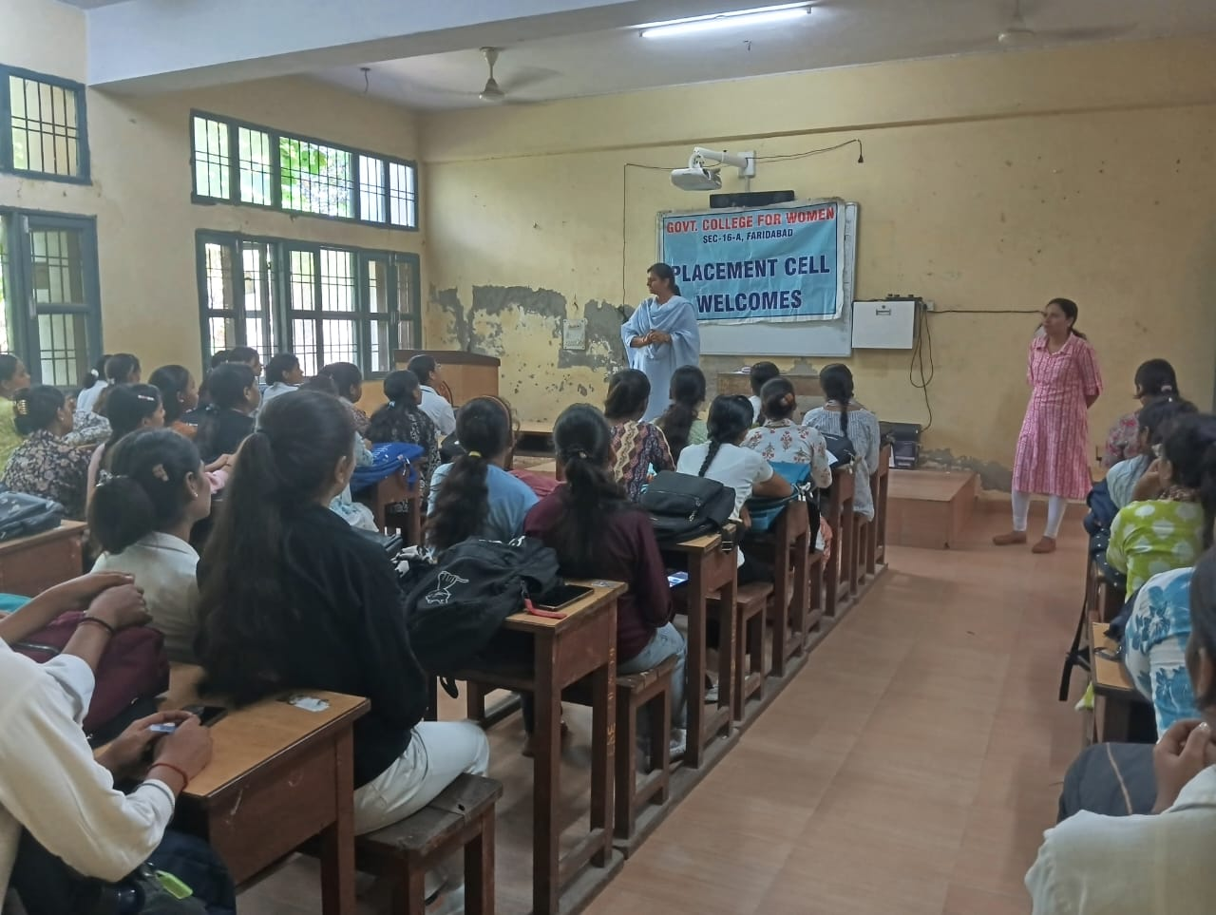
A total of 80 students enthusiastically participated in the seminar and interacted with the speaker to clarify their queries. The session proved to be highly informative and motivational for students aspiring to build a career in government services.

The Department of Commerce and Management, in collaboration with the Placement Cell of Government College for Women, Faridabad, organized an informative session on Financial Literacy on 23rd september to spread awareness among students about the importance of managing personal finances. The session aimed to equip students with the basic knowledge and skills required to make informed and effective decisions regarding their finances.
The session was conducted by a financial expert Ms. Jyoti,who explained key concepts such as budgeting, saving, investing, managing expenses, and understanding credit and debt. Real-life examples were shared to help students relate to the practical applications of financial literacy in everyday life.
The Honourable Principal, Dr. Sunidhi, addressed the participants and highlighted the growing need for financial awareness among youth. She encouraged students to take charge of their financial future by developing smart money habits early in life.
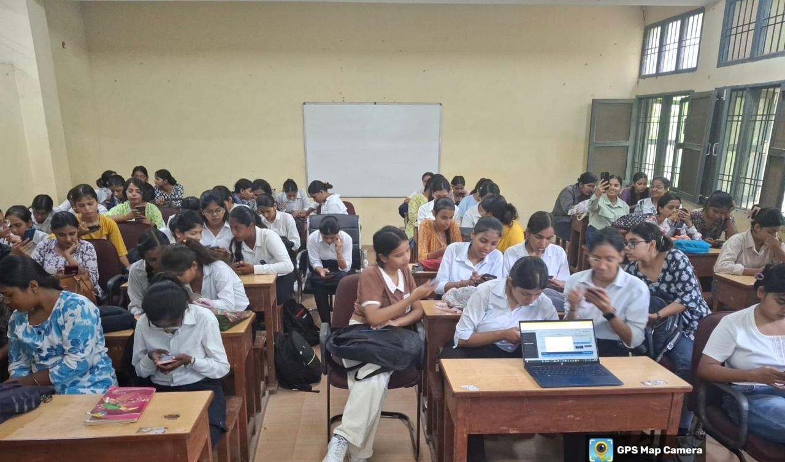
The event was well-received by students, with active participation and queries that reflected their enthusiasm to learn. The session was smoothly coordinated by the Placement Cell members, contributing to its overall success and effectiveness. concluded with a vote of thanks to the speaker and participants

