GOVERNMENT COLLEGE FOR WOMEN, FARIDABAD
DEPARTMENT OF COMPUTER SCIENCE
STARTUP IDEA COMPETITION REPORT
As part of the Entrepreneurship Pakhwada titled “Chhota Koi Kaam Nahin, Hunar Se Hi Naam Sahi”, a Startup Idea Competition was successfully conducted on 1st September 2025 at Government College for Women, Faridabad by the Department of Computer Science. The event aimed to promote creativity, innovation, and entrepreneurial thinking among students.The theme of the competition was:
“INNOVATIVE SOLUTIONS FOR A SELF-RELIANT INDIA”
Students were invited to submit a brief write-up (maximum 300 words) of their original startup ideas, focusing on innovation, sustainability, or social impact. Both individual and team entries (up to 3 members) were allowed in English or Hindi. The event witnessed enthusiastic participation from students across various courses, who presented creative and impactful startup ideas focused on innovation, sustainability, and social relevance. The entries were reviewed and shortlisted by Sh. Balbir Singh, Ms Roopam Dora and Ms. Priya Saini, who served as judges for the competition. The final presentation round of the shortlisted ideas was held successfully on 1st September 2025.
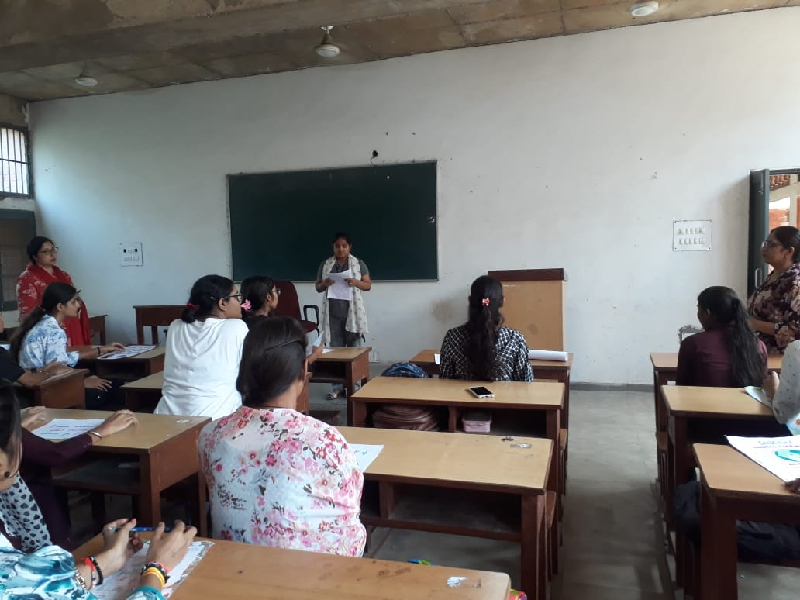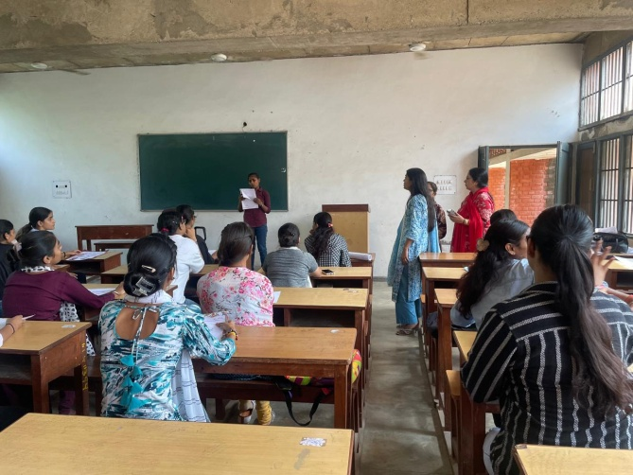

The winners of the competition were:
🥇 1st Position: Monika (Roll No. 22), BCA 3rd Year
🥈 2nd Position: Manisha (Roll No. 85), B.Com. 1st Year
🥉 3rd Position: Anjali Kumari (Roll No. 01), BCA 2nd Year
🥉 3rd Position: Hansani (Roll No. 01), B.Com 1st Year
Our esteemed Principal, Dr. Sunidhi, addressed the students during the event, shared insights on the role of startups in nation-building, and encouraged students to continue exploring innovative ideas. She also congratulated the winners and appreciated the efforts of all participants. The event was conducted under the guidance and supervision of Dr. Vijya Shridhar and Dr. Poonam Almadi, Department of Computer Science, and was a great success in fostering the spirit of entrepreneurship among students.

GOVERNMENT COLLEGE FOR WOMEN, FARIDABAD
DEPARTMENT OF COMPUTER SCIENCE
SLOGAN WRITING COMPETITION REPORT
As part of the Entrepreneurship Pakhwada celebrations titled “Chhota Koi Kaam Nahin, Hunar Se Hi Naam Sahi”, the Department of Computer Science, Government College for Women, Faridabad, organized a Slogan Writing Competition on 29th August 2025. The theme of the competition was:
✨ “Celebrating the Spirit of Entrepreneurship in India” ✨
Students were allowed to submit slogans in either English or Hindi, and entries could be handwritten or typed. The competition aimed to encourage students to creatively express their thoughts on entrepreneurship and self-reliance through impactful slogans. A total of 40 students participated in the competition, showcasing their creativity and understanding of entrepreneurship through powerful and thought-provoking slogans. The event was judged by Dr. Parul Rana, Madam Shalini Khurana and Dr. Jai Prakash who evaluated the slogans based on creativity, relevance to the theme, and originality.
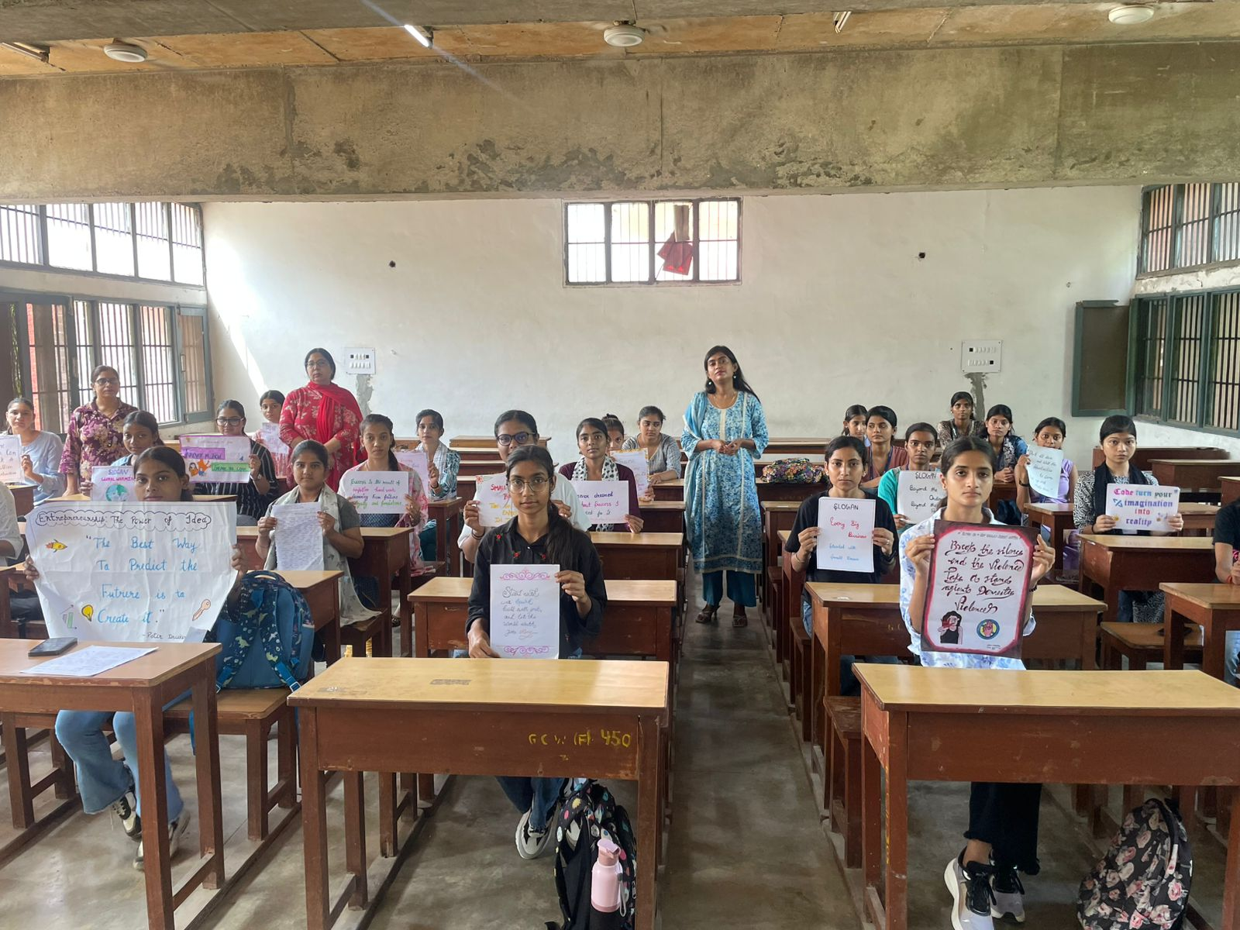
The winners of the competition were as follows:
🥇 1st Position: Sonam (Roll No. 35), BCA 2nd Year
🥈 2nd Position: Saraswati (Roll No. 140), B.Com. 2nd Year
🥉 3rd Position: Kasak (Roll No. 26), BCA 2nd Year

Our respected Principal, Dr. Sunidhi, addressed the students, appreciated their efforts, and encouraged them to continue nurturing their creative and entrepreneurial mindset. She also congratulated the winners and motivated all participants to take part in more such initiatives. The competition was successfully conducted under the guidance of Dr. ijaya Shridhar and Dr. Poonam Almadi, Department of Computer Science. The event was a great success and contributed meaningfully to promoting the spirit of innovation and entrepreneurship among students.

